CS 457 – Data modeling and Implementation Techniques

Instructor: Dr. Vidhyacharan Bhaskar

Homework 3A: (Due: Oct. 17, 2021 at 11.59 pm)

Elmasri book (7th edition):

HW 3A problems are from Chapter 4 (E-E-R modeling) of the 7th edition of Elmasri book.

1)Exercise 4.19

Identify all the important concepts represented in the library database case

study described below. In particular, identify the abstractions of classification

(entity types and relationship types), aggregation, identification, and

specialization/generalization. Specify (min, max) cardinality constraints

whenever possible. List details that will affect the eventual design but that

have no bearing on the conceptual design. List the semantic constraints separately.

Draw an EER diagram of the library database.

Answer=>

Entity names=> the members,

the books, the catalog, and the borrowing activity

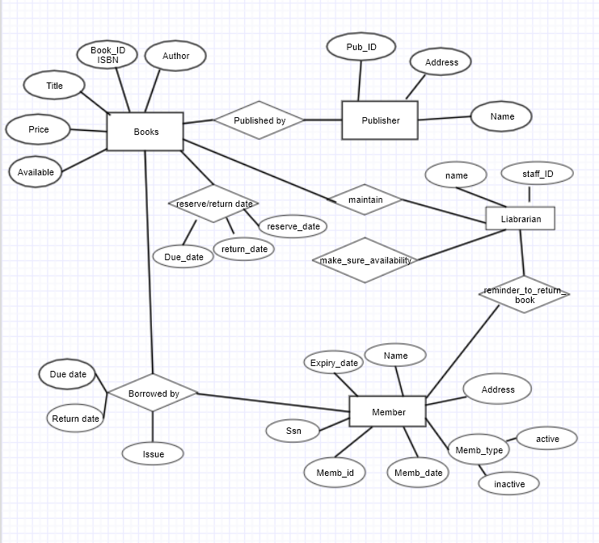

2)Exercise 4.21

Show how the SMALL_AIRPORT EER schema in Figure 4.12 may be represented in UML

notation. (*Note*: We have not discussed how to represent categories (union

types) in UML, so you do not have to map the categories in this and the following question.)

Answer=>

Entity=>airplanes, their owners, airport

employees, and pilots.

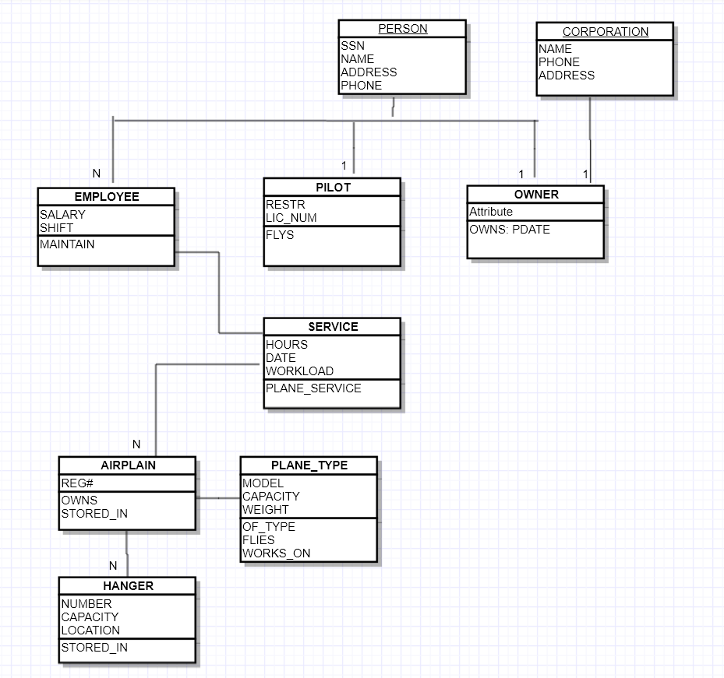

3)Exercise 4.24

Draw a UML diagram for storing a played game of chess in a database.

You may look at http://www.chessgames.com for an application similar to

what you are designing. State clearly any assumptions you make in your

UML diagram. A sample of assumptions you can make about the scope is

as follows:

Answer=> Entity=>chessboard, Piece, PieceSet, Player, Player type, Game,

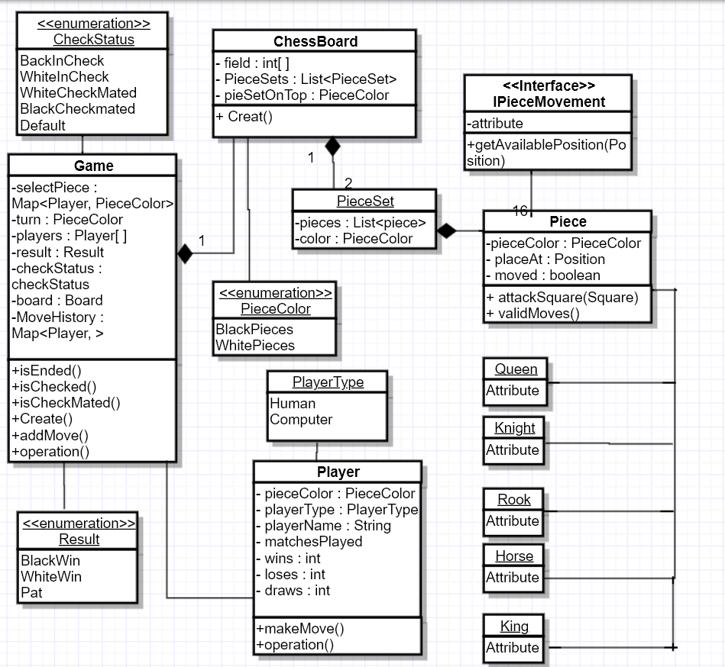

4)Exercise 4.27

Answer=> This describes the computer systems at a company

The database is used to keep track of computer, laptop, Desktop, operating system.

From the requirements for this database, the following information was collected

1. Entity computer is disjoint of laptop and desktop entity.These entities include attributes like SerialNo, CompCategory (game, business, school, etc), description. Key is a SerialNo.
2. ACCESSORY – attributes AcSerialNo, type, description,…and key is ACSerialNo
3. KEYBOARD- is subtype of ACCESSORY, with disjoin property, distinguished by the value “Keyboard” of the attribute type into accessory, includes attributes keyboard_type, keyboard_desc, etc.
4. MOUSE- is subtype of ACCESSORY, with disjoin property, distinguished by the value “Keyboard” of the attribute type into accessory, includes attributes mouse_type, mouse_desc, etc.
5. MONITOR - is subtype of ACCESSORY, with disjoin property, distinguished by the value “Keyboard” of the attribute type into accessory, includes attributes mouse_type, mouse_desc, etc.
6. LAPTOP - is subtype of COMPUTER, with disjoin property, distinguished by the value “Laptop” of the attribute type into accessory, includes attributes laptop_type, laptop_desc, etc.
7. DESKTOP - is subtype of COMPUTER, with disjoin property, distinguished by the value “Desktop” of the attribute type into accessory, includes attributes desktop_type, desktop_desc, etc.
8. SOFTWARE – attributes SetrialNo, LicNo, SoftCategory (eg. Textprocesor, Tabelarprocesor, Editor, Compiler, etc.), description, …. Key is SerialNo.
9. OPERATING_SYSTEM – is subtype of SOFTWARE, includes attributes op_sys_type, op_sys_bits, op_sys_desc, etc. -COMPONENT – attributes CompSerialNo, type, description, …, and key is

CompSerialNo

1. SOLD_WITH – is a relationship between COMPUTER and ACCESSORY
2. OPTIONS- is the relationship described inbetween DESKTOP and COMPONENTS
3. MEM_OPTIONS- is relationship described inbetween LAPTOP and MEMORY
4. INSTALLED- is relationship described between COMPUTER and SOFTWARE
5. INSTALLED_OS- is relationship described inbetween COMPUTER and OPERATING SYSTEM
6. SUPPORTS- is relationship between SOFTWARE and COMPONENT